CENWP-OD-B 9 May 2016

MEMORANDUM FOR THE RECORD

SUBJECT: 16BON12 MFR – Adult salmonid mortalities in the PH1 unit 8B tail log slot.

On 7 May, a Project Biologist noted dead fish floating in the PH1 tail log slot for unit 8B. A dead fish odor had been noted in the area the week prior by multiple biologists but inspections of the area had come up empty. The tail log slot is upstream of the PH1 collection channel (CC) under the roadway and only the very upstream portion of the slot area is visible from the CC walkway, from a PH1 diffuser bridge. Water in the tail log slot can only be seen when tailwater is high enough. A schematic of the area is shown in Figure 1. Generalized water levels are shown in blue, with the location of the dead fish indicated by the red circle and anticipated trajectory of the fish as the red arrow. It’s unknown when the fish moved into the tail log slot. Unit 8 has been out of service since 22 February 2016 with no tail logs installed (open to the tailrace with no water flow).

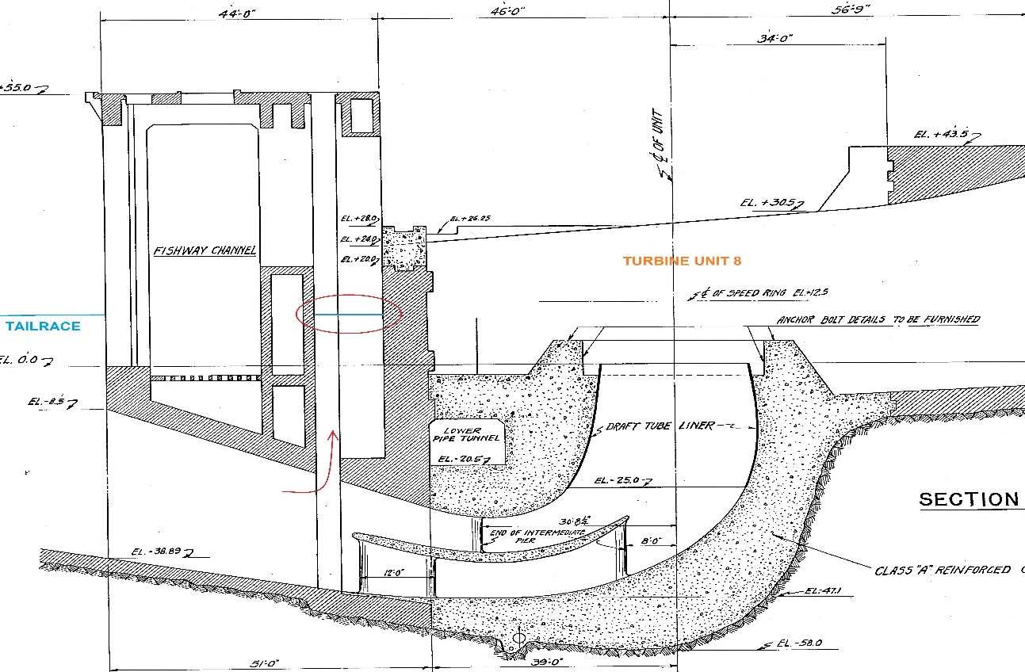
Figure 1. Schematic of the PH1 turbine outflow area. The tailrace is to the left and the forebay to the right. The suspected point of entry of fish into the area described is denoted as the red arrow. The dead fish were noted in the location of the red circle. Unit 8 has been out of service with no flow or tail logs since 22 February 2016.

On 9 May, the first available work day, the structural crew removed the roadway deck plates located above the tail log slot at the request of Project Fisheries in order to allow a clear visual inspection of the area. Project Biologists estimated ~70 dead adult salmonids were floating in the unit 8B tail log slot. The slot for 8A was also investigated; no mortalities were found but at least two salmonids were noted swimming in the slot. No means of entry to the area was noted other than the tail log slot itself (red arrow in Figure 1).

Information collected is provided below:

A. Species – Unknown salmonids
B. Origin – Unknown
C. Lengths – Unknown
D. Tags – Unknown
E. Marks and Injuries found on carcass – Unknown
F. Cause and Time of Death – Unknown. Dead fish odor was present one week prior.
G. Future and Preventative Measures – Under investigation. The mechanism causing this incident to occur is currently unknown. The HVAC cooling water for PH1 discharges a small amount of water into tail log slots 8B and 9A. This could potentially have provided attraction water. The cooling water is now only being discharged into unit 9, which is running. Other measures are actively being pursued.

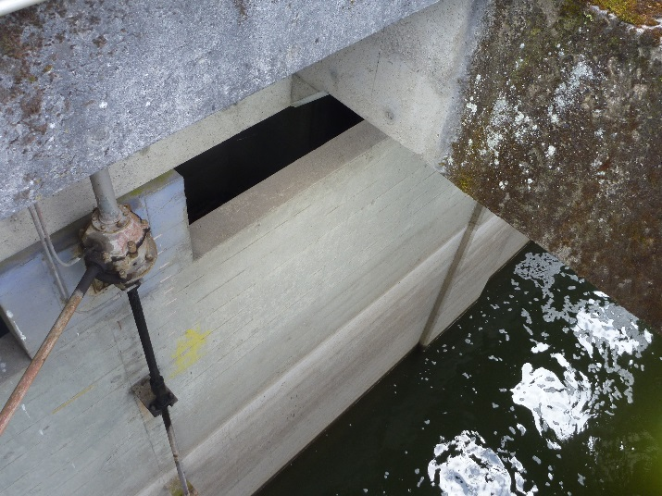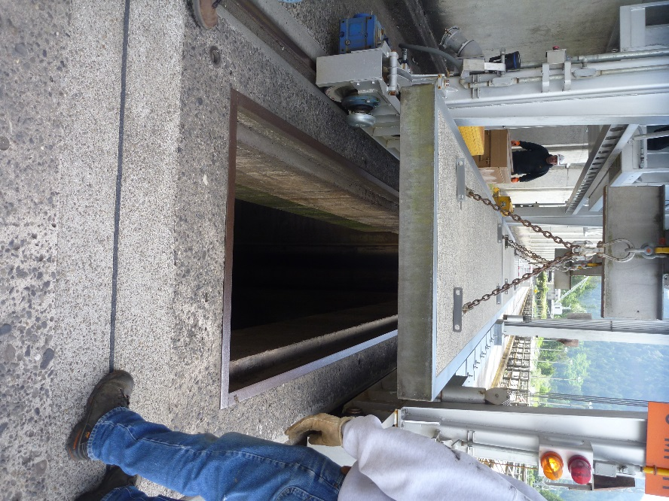
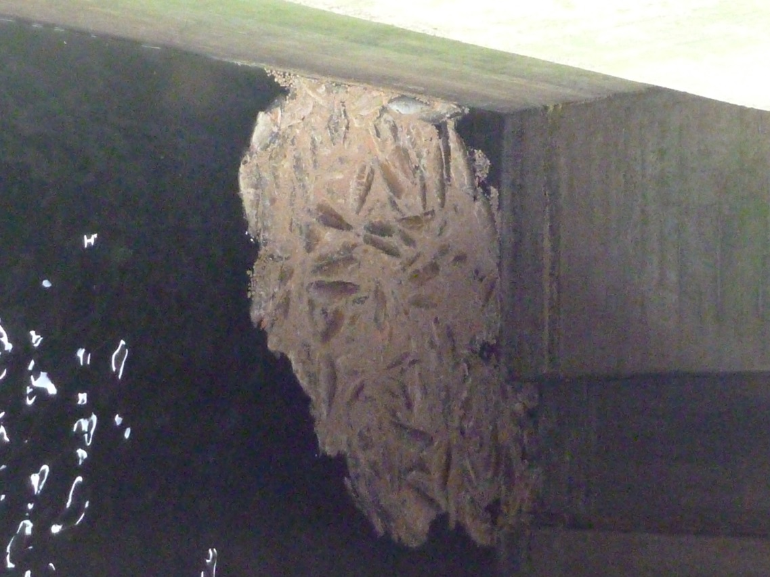
Sincerely,
Bonneville Fisheries

